

**E-COMMERCE PROJECT**

***By***

**GEORGE MUTINDA KILONZO**

**APPROVAL**

This project has been submitted by the following student:

|  |  |
| --- | --- |
| GEORGE MUTINDA KILONZO | CIS/00006/023 |

**DECLARATION**

This is to certify that this project is my original work. No part of this work has been submitted elsewhere. Any material reproduced in this project has been properly acknowledged.

Abstract

The business-to-consumer aspect of product commerce (e-commerce) is the most visible business use of the World Wide Web. The primary goal of an e-commerce site is to sell goods online.

This project deals with developing an e-commerce website for Online Product Sale. It provides the user with a catalog of different product available for purchase in the store. In order to facilitate online purchase a shopping cart is provided to the user. The system is implemented using a 3-tier approach

These include multi-tiered architecture, server and client side scripting techniques, implementation technologies such as HTML5,CSS and JAVASCRIPT. This is a project with the objective to develop a basic website where a consumer is provided with a shopping cart application and also to know about the technologies used to develop such an application. This document will discuss each of the underlying technologies to create and implement an e-commerce website.

**ACKNOWLEDGEMENT**

In completing this graduate project I have been fortunate to have help, support

and encouragement from many people. I would like to acknowledge them for their

cooperation.

First, I would like to thank Mr.Kilonzo, my project advisor, for

guiding us through each and every step of the process with knowledge and support.

Thank you for your advice, guidance and assistance.

**TABLE OF CONTENTS**

|  |  |
| --- | --- |
| Name | Page |
| Introduction……………………………………………………………………………. | 8 |
| Project Description……………………………………………………………………. | 9 |
| Diagrams………………………………………………………………………………. | 10-11 |
| Design And Implementation Of E-Commerce Site For Online Shopping……….. | 12 |
| Web Page every option Details……………………………………………………… | 12-19 |
| Non-Functional / Operational Requirement………………………………………...  References ………………………………………………………­­­­­­…………………. | 20  20 |

**INTRODUCTION**

E-commerce is fast gaining ground as an accepted and used business paradigm. More and more business houses are implementing web sites providing functionality for performing commercial transactions over the web. It is reasonable to say that the process of shopping on the web is becoming commonplace.

The objective of this project is to develop a general purpose e-commerce store where any kind of product can be bought from the comfort of home through the Internet. However, for implementation purposes, this paper will deal with an online shopping for baby product

An online store is a virtual store on the Internet where customers can browse the catalog and select products of interest. The selected items may be collected in a shopping cart. At checkout time, the items in the shopping cart will be presented as an order. At that time, more information will be needed to complete the transaction. Usually, the customer will be asked to fill or select a billing address, a shipping address, a shipping option, and payment information such as bKash, or Cash on Delivery. An e-mail notification is sent to the customer as soon as the order is placed.

**PROJECT DESCRIPTION**

* Any member can register and view available products.
* Only registered member can purchase multiple products regardless of quantity.
* Contact Us page is available to contact Admin for queries.
* There are four roles available:
* Visitor
* User
* Visitor can view, search, compare available products.
* User can view and purchase products.

**DESIGN AND DEVELOPMENT ENVIRONMENT**

* HTML5
* CSS3
* JAVASCRIPT
* VISUAL STUDIO CODE

### Diagrams of buy Shopping Website Management System

**Login Activity:**

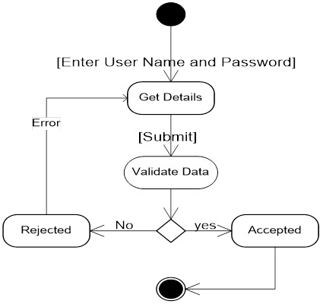

**UserActivity Diagram:** 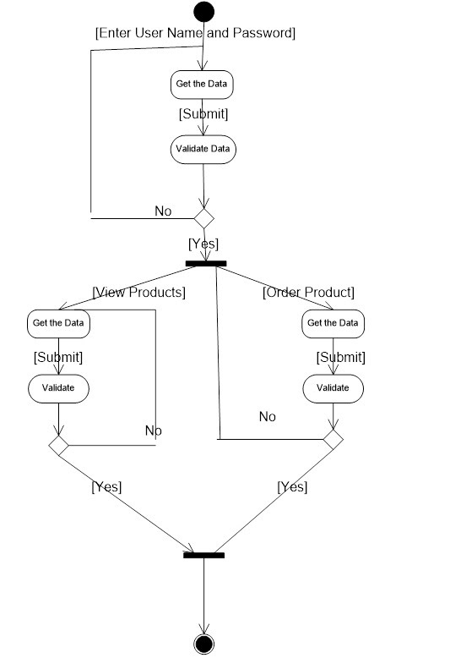

**DESIGN AND IMPLEMENTATION OF E-COMMERCE SITE FOR ONLINE SHOPPING**

**Web Pages details:**

* Home Page
* Product listing page
* Product detail page
* Shopping cart page
* Checkout page
* About us page
* Contact us page

**HOME PAGE: This is the home page or welcome page.**

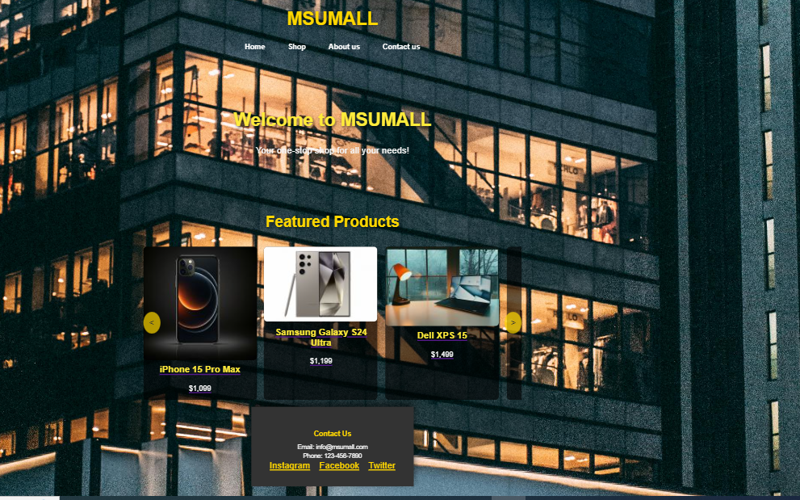

**PRODUCT LISTING PAGE**

This is the one of the front end page part of our buy ecommerce .All products we show here with different categories and price ranges as shown in thw

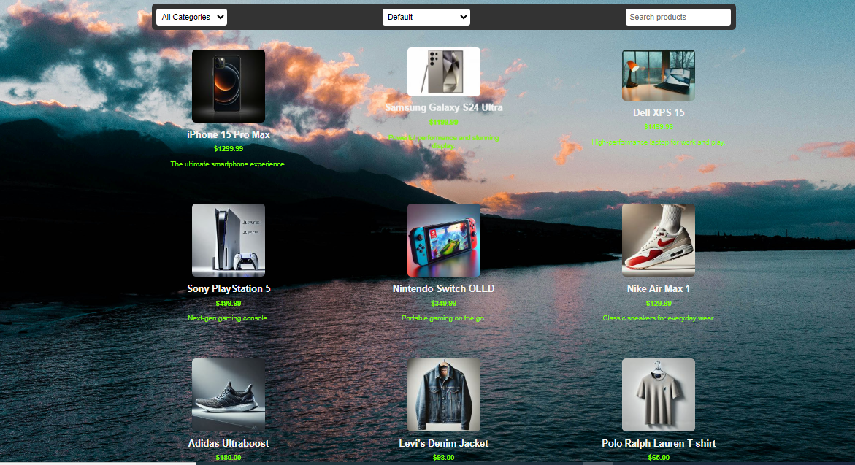

**MENU BAR**

This is the menu of our buy ecommerce.







***Clicking any product will redirect to Product Details Page. Which contains product information, description of products, ratings & reviews and recommended items. With Add to Cart Button and View Cart Button.***

**PRODUCT DETAIL PAGE.**

**ADD TO CART BUTTON & VIEW CART BUTTON**

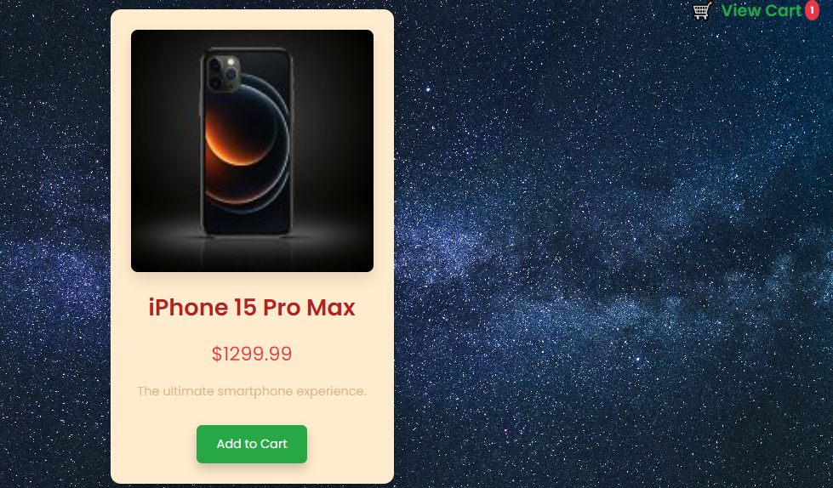

**ADD TO CART BUTTON & VIEW CART BUTTON.**

Add to Cart button adds the product to cart. View Cart icon can redirect the product detail page. View Cart icon contains the number of Cart product. View Cart icon redirects to Shopping Cart page.





**SHOPPING CART PAGE:**

After redirecting from Product Detail Page to Shopping Cart page.

**The Shopping Cart Page shows:**

* **the total number of products ordered**
* **total price of the products**
* **remove product button**
* **add items button**
* **proceed to checkout button.**

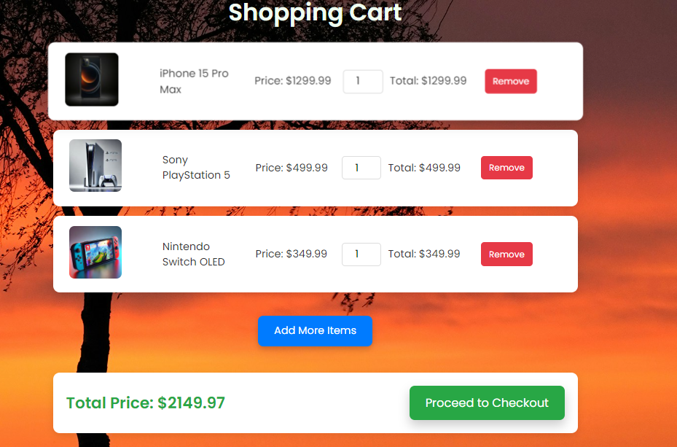

**ADD MORE ITEMS BUTTON,PROCEED TO CHECKOUT BUTTON AND REMOVE BUTTON.**

Add more items button redirects the page to Product Listing Page to add more products.The remove button sorts the wanted and unwanted products.

 



**CHECKOUT PAGE:**

**Order Summary:**

* **Subtotal:** Displays the total cost of items before taxes and shipping.
* **Tax:** Shows the calculated tax amount.
* **Total:** Displays the final total amount, including tax and shipping.

**Shipping Information:**

* **Full Name:** Field for the customer's full name.
* **Phone Number:** Field for the customer's phone number.
* **Location:** Dropdown menu for selecting the delivery location.

**Payment Information:**

* **Payment Method:** Dropdown menu for selecting the payment method (e.g., M-Pesa, card).
* **M-Pesa or Card Number:** Field for entering the payment details.

**Action Button:**

* **Proceed to Payment:** Button to initiate the payment process.

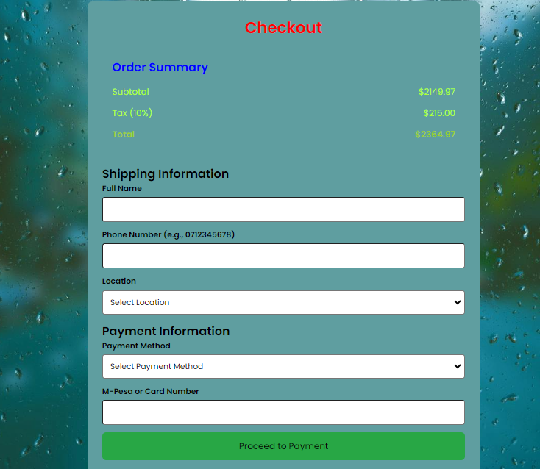

**ABOUT US PAGE:**

Each card contains:

* **Team Member's Name:** The name of the individual.
* **Profile Picture:** A photo of the team member.
* **Job Title:** The team member's role or position within the company.
* **Brief Bio:** A short description about the team member's background, experience, or interests.

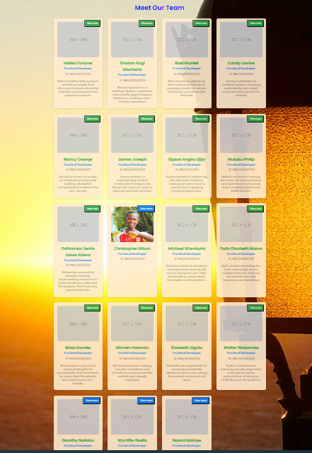

**CONTACT US PAGE.**

**Form Fields:**

* **Full Name:** Requires the user to enter their full name.
* **Email Address:** Requires the user to enter their email address.
* **Subject:** Requires the user to enter the subject of their message.
* **Message:** A text area where the user can enter their message.

**Action Button:**

* **Send Message:** A button that, when clicked, presumably submits the form data to a server-side script or email address.

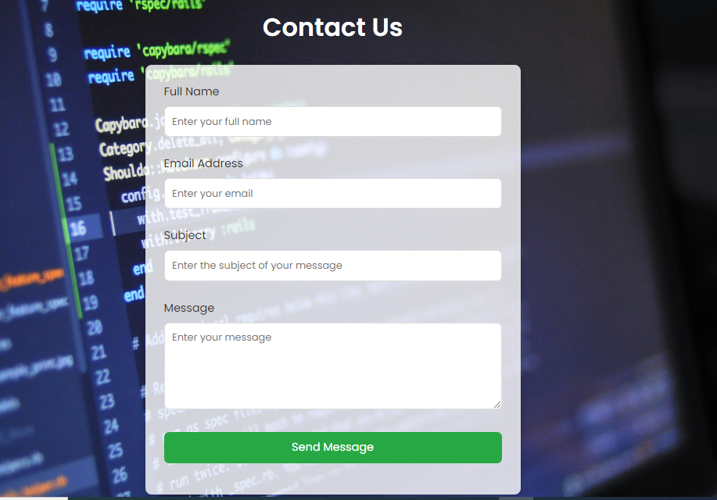

**NON-FUNCTIONAL / OPERATIONAL REQUIREMENTS**

* **Security**
* Pages of the website must be access in the way they were included files shall not be accessed outside of their parent file.
* **Efficiency and Maintainability**
* Page loads should be returned and formatted in a timely fashion depending on the request being made.

**CONCLUSION:**

The Internet has become a major resource in modern business, thus electronic shopping has gained significance not only from the entrepreneur’s but also from the customer’s point of view. For the entrepreneur, electronic shopping generates new business opportunities and for the customer, it makes comparative shopping possible.

As per a survey, most consumers of online stores are impulsive and usually make a decision to stay on a site within the first few seconds. “Website design is like a shop interior. If the shop looks poor or like hundreds of other shops the customer is most likely to skip to the other site.

Hence we have designed the project to provide the user with easy navigation, retrieval of data and necessary feedback as much as possible. In this project, the user is provided with an e-commerce web site that can be used to buy all types products online.

In this project the ‘add to cart’ functionality made by javascript without using any plugin and payment system is not included properly in this project .

**REFERENCES:**

<http://www.w3schools.com/>

http://www.php.net

**================ END ===================**